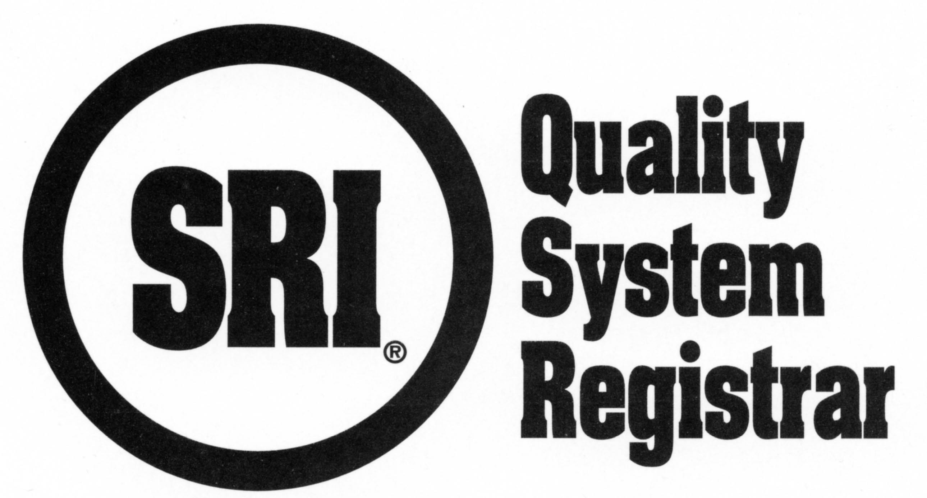
R20.107 AS9100/9120 Readiness Review

IMPORTANT NOTICE: According to accreditation body requirements, failure to submit the information in a timely manner, omit materials, or provide inaccurate information, will result in a nonconformance being issued by the Lead Assessor. Information provided on this form should be compared to SRI’s Auditee Information sheet, R20.62, discrepancies need to be addressed.

The organization applying for certification to AS9100/9120 shall provide SRI with the following information and documentation during an on-site, Stage 1 “Readiness Review.” This form, R20.107, must be completed by the organization for each site to be registered. This information and documentation is required as indicated in AS9101E for auditing management systems according to AS9100/9120. Postponement of the on-site Stage 1 review could result in delaying your Stage 2 registration audit dates. If changes occur between Stage 1 and Stage 2, the client is required to notify the SRI office in writing. Failure to do so will result in a nonconformance being issued by the Lead Assessor.

Prior to each scheduled surveillance and renewal audit event, the AS9100/9120 registered client shall provide SRI with the following information (as applicable for surveillance/renewal events) and documentation. This information and documentation is required as indicated in AS9101E for auditing management systems according to AS9100/9120. This information is required prior to the surveillance/renewal audit and must be received at SRI / submitted to the assigned Lead Assessor six (6) weeks prior to the scheduled event and accepted by the Lead Assessor at least four weeks prior to the scheduled event. Failure to submit the information in a timely manner, or to omit materials, will result in a nonconformance being issued by the Lead Assessor and will initiate the “delisting” process. Additional time on-site is then required to be added to the upcoming event to review the requisite materials.

Information to be reviewed at Stage 1 (on-site), Surveillance and Renewal (off-site) events. The first four items are required at Stage 1 and Renewal events unless changes would require review at surveillance:
- Management system documentation (Level I and II - policies and required procedures) for each site to be audited.
- International Traffic in Arms Regulations (ITAR) status
- Completed Process Matrix, (AS9101E, Form 2), for AS9100/9120. Client to use the WORD form (or equivalent) to indicate the processes and related clauses by placing an X in the appropriate clause(s).
- Provide a description of processes showing their sequence and interactions, including the identification of any outsourced processes. NOTE: The processes can be depicted in various ways [e.g., process maps, turtle diagrams, SIPOC method (breakdown of supplier, inputs, process steps/tasks, outputs, customer,) octopus]. Processes (maps, turtles, etc.) must be provided at Stage 1 for planning purposes.
- Customer Feedback Requests through OASIS
- Percentage of revenue relating to aviation, space and defense business and other industries including number of employees and shift information
- Internal audit and management review planning and results.
- Nonconformity data
- Customer Satisfaction and Customer complaint status (summary sheet of customer complaints), and any Customer Status (limited, suspension, probation, withdrawal)
- On time delivery (OTD)
- Service Provision (if applicable) – Analysis of service data, actions taken
- Responsiveness to the Customer and internal requests
- Current number of employees and shift information

For a Stage 1 event, the information must be completed and available
on-site for the SRI auditor’s review.

For a surveillance or renewal event, 6 weeks prior to a scheduled surveillance/renewal audit, forward the completed R20.107 form and information to our office via mail, fax, or e-mail:
SRI Quality System Registrar, 300 Northpointe Circle, Suite 304, Seven Fields, PA 16046
Tel.: 724-934-9000 • Fax: 724-935-6825
E-mail: to your customer care coordinator [first initial+last name]@sriregistrar.com
(e.g., smazur@sriregistrar.com)

Audit Planning – for all AQMS (Stage 1, Surveillance, and Renewal) events: The audit Team Lead shall use the customer feedback requests, including those received through OASIS to assist in planning the audit event. The audit activities shall be prioritized based upon performance data that can impact the customer (Customer Concerns, Customer Special Status) and on low PEAR performance. Additionally, a list of PEARS and performance metrics (process effectiveness) must be supplied.
Completed by |  |  | Date
E-mail Address |  |  | Phone
Organization name
Street Address, City, State
Facility to be registered (if different than above)
Remote Support, if any Location(s)/Address(es) and Processes performed
Language of the Audit |  | OASIS Administrator
Current Aerospace Customers

*F/P/T – Full time, part time and temporary employees **E = early shift, D = day shift, L = late shift, N = night shift
Business | Organization Revenue |  | Personnel Numbers |  | Organization Shift Patterns  Number of Employees  Example: E/D/L/N** include shift times
 | Revenue  (optional) | % of Total Revenue | *F/P/T – All shifts | % of Total Workforce
Aviation, Space, & Defense |  |  |  |  | Shift(s):
Other: |  |  |  |  | Shift(s):
Remote Support Location: | n/a | n/a |  | n/a | Shift(s):
Remote Support Location: | n/a | n/a |  | n/a | Shift(s):
Remote Support Location: | n/a | n/a |  | n/a | Shift(s):
Total Employees:

Aerospace Customers with Highest Revenue (pages can be added if required) | Trend of Quality Performance – Summary Previous 12 months | Trend of OTD Performance - Summary Previous 12 months
 | Satisfactory Unsatisfactory | Satisfactory Unsatisfactory
 | Satisfactory Unsatisfactory | Satisfactory Unsatisfactory
 | Satisfactory Unsatisfactory | Satisfactory Unsatisfactory
 | Satisfactory Unsatisfactory | Satisfactory Unsatisfactory
 | Satisfactory Unsatisfactory | Satisfactory Unsatisfactory

Certificate Structure definition and information listed below. Confirm all requirements of the selected structure apply. Incorrect selection could adversely impact audit result and registration status.
Current Certification Structure Single Site,  Multiple Site, Campus, Several Sites,  Complex | If Change is required - Organization should be identified as: Single Site, Multiple Site,  Campus, Several Sites, Complex
Justification for Structure Change, if any:

- “Single Site” - An organization that operates at one site or a grouping of sites in one geographic location and issued one certificate with one address. Stand-alone, self-supporting organization
- No value stream dependencies from related companies or between buildings.
- Operating under the same quality management system.
- One address and/or multiple addresses with each performing the same manufacturing activity and/or different activities that do not function as a value chain (e.g. building one = wing assemblies, building two = wire harness assemblies) or all manufacturing is at one address, but supporting office functions are at a second address. If the scope of certification for a “Single Site” certification structure contains more than one address, then all addresses must be on the certificate and the “single address” entered into OASIS would be the address on record as being contracted with SRI.
- If a value chain relationship exists between multiple buildings (i.e. WIP is moved between buildings), see Campus below.
- “Multiple Sites” - An organization having an identified central function (the central office, but not necessarily the headquarters of the organization) at which certain activities are planned, controlled, or managed and a network of sites, in more than one geographic area, at which such activities are fully or partially carried out. With the exception of the central office the processes within each of the sites are substantially the same and are operated to the same methods and procedures. One certificate is issued listing the central function and all sites including sub-scopes for each. All Sites shall have a legal or contractual link with the central office;
- One quality management system with central control, management review, and internal audit.
- Central office can require other sites implement corrective action.
- Central collection and analysis of data, and with the ability to initiate organizational change.
- Complies with IAF MD 1,"Multi-site Organization" definition and eligibility requirements.
- All quality management system processes at all sites have to be substantially (i.e., 80%) the same and are operated to the same methods and procedures.
- Some sites may conduct fewer processes than others.
- One address per site.
- “Campus” - An organization having an identified central function (the central office, but not necessarily the headquarters of the organization) at which certain activities are planned, controlled, or managed; and that has a decentralized, sequential, linked product realization process. For the purposes of this standard, it is referred to as a value stream where the outputs from one site are an input to another site, which ultimately results in the final product or service. One certificate is issued listing one controlling address and scope. Each site within the campus will have an address and sub-scope activity that describes the manufacturing activities within each building. All sites shall have a legal or contractual link with the central office.
- One quality management system with central control, management review, and internal audit.
- Central office can require other sites implement corrective action.
- Central collection and analysis of data, and with the ability to initiate organizational change.
- The outputs from one site are an input to another site to realize the final product or service; a single value stream.
- Can be dissimilar processes at different sites or combination of sites that contribute to the same overall product or service.
- More than one product or service may be realized provided they are substantially (i.e., >80%) the same (e.g., a family of products) and realized through the same methods and procedures.
- One address per campus.
- “Several Sites” - An organization having an identified central function (the central office, but not necessarily the headquarters of the organization) at which certain activities are planned, controlled, or managed and a network of sites, that do not meet the criteria for either a multiple site or a campus organization. One certificate is issued listing the central function and all sites. Certificate includes an overall scope statement and sub-scope statement for each site. All sites shall have a legal or contractual link with the central office.
- One quality management system with central control, management review, and internal audit.
- Central office can require other sites implement corrective action.
- Central collection and analysis of data, with the ability to initiate organizational change.
- Processes at each of the sites are not substantially similar (i.e., 80% similar).
- Processes may be operated to the same or different methods and procedures that are controlled through one common quality management system.
- Sites realize different products or services.
- One address per site.

International Traffic in Arms Regulations (ITAR) responsible Yes No

Provide a description of the aerospace products manufactured:

Product design responsible (includes subcontracted design)? Yes No

Identify any regulatory requirements (OSHA, EO, EPA, DOT, FARs, DFARs, ITAR, etc.) applicable to
the AQMS:

Customer Status, explain: (limited, suspension, probation, withdrawal)

Changes since the last assessment [QMS, equipment, # of employees, shifts, product, scope (for multi-site or campus: sub-scopes), processes, new customer(s), etc.]: Yes No – if yes, explain

Are you still producing product for the aerospace industry: Yes No - If no, explain:

Identify all product realization processes and the support processes in the organization (must match completed Form 2 of AS9101E, Process Matrix for AS9100/9120) and enter each below in the Process column.
Processes as Identified in the System Manual | Objective (Specific Target Values) | Actual Performance – Current Measurement
Example only: Shipping | 100% on time delivery | Current 90%.

For SRI Auditor Use only -
P L E A S E P R I N T
Complete and return this portion/page only to SRI. Please complete the appropriate areas below based on the type of readiness review you are performing. Information relating to the outcome of the Stage 1 readiness review.
Company name
Location

For a Stage 1 Event: SRI has conducted a Stage 1 audit for this site. The Stage 1 audit included a review of the management system documentation level 1 and 2 (unless the management system documentation was corporate and reviewed at a prior event) and all Readiness Materials as indicated on this form, R20.107, for this site. The Stage 1 event provided a focus for planning the Stage 2 audit by gaining a sufficient understanding of the:
- Client’s location and site conditions
- Client’s status and understanding regarding the requirements of the cited Standard
- Site specific documentation
- Information regarding the scope and/or sub-scopes and processes, etc.
    - NOTE: Scope and sub-scope requirements are linked to the certification structure. Campus requires a sub-scope by building. Multi-site requires a sub-scope by site. Site requires a scope comprising all included activities.
- Allocation of resources for Stage 2 or any other audit event – Contact SRI customer care coordinator should the auditor need to add audit time for any reason such as risk, complexity, increased scope, translation, verifying corrective actions, etc. Refer to ANAB Heads Up 318.
- Verification of client and/or design subcontractors to have appropriate capability to meet clause 7.3, including interfaces between client and subcontractor.
- Client’s website visited to confirm company name, address, structure, other linkages, other support, scope and/or sub-scopes vs what is on the website, additional addresses, to ensure that misleading statements regarding certification are not being made or implied, etc.
Stage 1 Readiness Review Only - To be completed by SRI Auditor only:
Stage 1, Readiness Review, Duration and Results
Duration: Stage 1 audit scheduled mandays |  |  |  | Actual mandays conducted
Results:
Ready - The organization has received a “ready” for Stage 2 registration activity result.
SRI Lead Auditor Signature: |  |  |  |  | Date:
Not Ready - Should the organization receive a “not ready” for Stage 2 registration activity, another on-site Stage 1 event should occur.
Comment is required if client is to respond to cited issues/concerns identified at Stage 1 prior to the Stage 2. Ready status is contingent upon receipt of response(es) to cited issues/concerns:
SRI Lead Auditor Signature: |  |  |  |  | Date:
Number of Additional Days of on-site Readiness Review required: |  |  |  |  | When:

Client’s Acknowledgment (should another on-site Stage 1 be required):
Name: |  | Date:
Signature:

For SRI Auditor Use only -
P L E A S E P R I N T
Company name
Location
Surveillance/Renewal #

Surveillance/Renewal Readiness Review -To be completed by SRI Auditor only: Return this portion/page only
Note to auditor: If the client fails to submit this information in a timely manner, omit materials, or provide inaccurate information, you are required to write a nonconformance.
- Auditor Reminder: Client’s website visited to check for appropriate use of marks and to confirm company name, address, structure, other linkages, other support, scope and/or sub-scope vs what is on the website, additional addresses, to ensure that misleading statements regarding certification are not being made or implied, etc. Allocation of resources for any audit event - Contact SRI customer care coordinator should the auditor need to add audit time for any reason such as risk, complexity, increased scope, translation, verifying corrective actions, etc. Refer to ANAB Heads Up 318.

An issue has been identified during a review of the surveillance readiness materials. This issue will be followed up on-site at the scheduled event. The audit plan has been adjusted to capture this issue.

Issue Description:
Objective Evidence Observed:

The renewal audit plan considers the performance of the management system over the previous three year period of certification and the review of the surveillance reports issued over the previous three year registration period. Poor performance requires additional on-site audit time.

Yes No - If no, explain:

Results:
Ready - The organization has received a “ready” for surveillance result.

SRI Lead Auditor Signature: |  |  | Date:
Not Ready - Should the organization receive a “not ready” for Surveillance, added on site time may occur.
SRI Lead Auditor Signature: |  |  | Date:
Number of Additional Days of on-site Readiness Review required: |  |  | When:

